Late Shri. Vishnu Waman Thakur Charitable Trust's Bhaskar Waman Thakur College of Science, Yashwant Keshav Patil College of Commerce, Vidhya Dayanand Patil College of Arts

(Viva College - Virar)

**T.Y.B.SC (COMPUTER SCIENCE)**

TITLE OF THE PROJECT

**WEB APPLICATION WITH LEARN AND EARN FEATURES**

SUBMITTED BY:

**SHIVAM ASHOK CHAURASIA**

**ROLL NO: 9**

**Project Guide: Ms. Shweta Yande Ma’am**

**ACKNOWLEDGEMENT**

I would like to thank my Project Guide: Ms. Shweta Yande Ma’am for helping me with this project. She allowed me to work on this project. I got to learn a lot from this project about Html, CSS, Python, Sqlite3 database and Django frameworks with fully function frontend and backend etc. I would also like to thank our CS Department HOD Mrs. Jagruti Ma’am for

her valuable guidance and support on the completion of this project.

I also pay my gratitude to all the programming community out there for providing resources and ideas.

Finally, I would also like to thank my parents and friends for moral support which me a lot in finalizing this project within the limited time frame.

**TABLE OF CONTENTS**

|  |  |  |
| --- | --- | --- |
| Sr.no. | Topic | Page no. |
| 1 | Introduction | 4 |
| 2 | Requirement Specification | 5-6 |
| 3 | Gantt Chart | 7 |
| 4 | UML Diagram | 8-11 |
| 5 | Schema Design | 12 |
| 6 | Coding | 13-24 |
| 7 | Testing | 25 |
| 8 | Reports | 26-29 |
| 9 | Conclusion and Future Enhancement | 30 |
| 10 | Reference | 31 |

**INTRODUCTION**

The main aim of this project is the student can learn from anywhere across the world through our web application called “CODEASSET” and if they have skills, they can also earn by joining us as a freelancer to improve our web application. This is a simple learn and earn online platform which helps those students who was not able to pay high-cost charges on other premium platforms.

So, keeping these things in mind I have computerized my small project work

“WEB APPLICATION WITH LEARN AND EARN FEATURES” I have maintained this project on a suitable and advance language such as python, html and CSS.

1. A free learning platform
2. Learn and Earn policy
3. Gives opportunity to freelancer

**DRAWBACK IN EARLIER SYSTEM**

When we look at the corners of the world today, we can see children attending premium courses to upgrade their skills by learning, and progressing. However, in some region these things are not free, which can lead unavailability. That’s why I choose this project to solve these major drawbacks in our earlier system.

* **Drawbacks list**

1. High-cost with premium charges
2. Lack of opportunity
3. No earning sources

**PROPOSED SYSTEM**

It is a network web application; more than one user can use it. It is a type of tutorial and commercial online software which has job opportunity as a freelancer anyone who has skills of web development, they can join us through job portal according to the minimum criteria and terms. The second module is contact page in this module if anyone wants to contact us for business propose they can contact us through this portal. The Third module is for learning purpose and courses. Fourth module is a feedback form where our page visitor can give us feedback or query easily and the last is module About Us the page for those who really wants to know about us.

**REQUIREMENT SPECIFICATION**

**I. MODULES**

1. **Jobs:** Used for managing the job request
2. **Contact:** Used for managing the contacts in the database
3. **Tutorial:** Used for learning
4. **Feedback page:** Used for feedback management and handling

All these modules with attractive learning home page.

**II. HARDWARE AND SOFTWARE REQUIREMENTS**

**A. Hardware**

1. CPU: Dual Core
2. Motherboard: AMD Ryzen 3
3. RAM: 4.00 GB (3.44 GB usable)
4. HDD: 1 TB

**B. Software**

1. Operating System: Windows 10 Home Single Language
2. IDE: VSCode, PowerShell and Python Interpreter
3. Server: SQLite
4. Browser: Chrome or Microsoft edge

**III. FRONTEND AND BACKEND**

**1.HTML**

[Web browsers](https://en.wikipedia.org/wiki/Web_browser) receive HTML documents from a [web server](https://en.wikipedia.org/wiki/Web_server) or from local storage and [render](https://en.wikipedia.org/wiki/Browser_engine) the documents into multimedia web pages. HTML describes the structure of a [web page](https://en.wikipedia.org/wiki/Web_page) [semantically](https://en.wikipedia.org/wiki/Semantic_Web) and originally included cues for the appearance of the document.

[HTML elements](https://en.wikipedia.org/wiki/HTML_element) are the building blocks of HTML pages. With HTML constructs, [images](https://en.wikipedia.org/wiki/HTML_element#Images_and_objects) and other objects such as [interactive forms](https://en.wikipedia.org/wiki/Fieldset) may be embedded into the rendered page. HTML provides a means to create [structured documents](https://en.wikipedia.org/wiki/Structured_document) by denoting structural [semantics](https://en.wikipedia.org/wiki/Semantics) for text such as headings, paragraphs, lists, [links](https://en.wikipedia.org/wiki/Hyperlink), quotes and other items.

**2.CSS**

CSS is designed to enable the separation of presentation and content, including [layout](https://en.wikipedia.org/wiki/Page_layout), [colours](https://en.wikipedia.org/wiki/Color), and [fonts](https://en.wikipedia.org/wiki/Typeface). This separation can improve content [accessibility](https://en.wikipedia.org/wiki/Accessibility); provide more flexibility and control in the specification of presentation characteristics; enable multiple [web pages](https://en.wikipedia.org/wiki/Web_page) to share formatting by specifying the relevant CSS in a separate .CSS file, which reduces complexity and repetition in the structural content; and enable the .CSS file to be [cached](https://en.wikipedia.org/wiki/Cache_(computing)) to improve the page load speed between the pages that share the file and its formatting.

**3.SQLite**

SQLite is a software library that provides a relational database management system. The lite in SQLite means lightweight in terms of setup, database administration, and required resources.

**4.DJANGO**

Django's primary goal is to ease the creation of complex, database-driven websites. The framework emphasizes [reusability](https://en.wikipedia.org/wiki/Reusability) and "pluggability" of components, less code, low coupling, rapid development, and the principle of [don't repeat yourself](https://en.wikipedia.org/wiki/Don%27t_repeat_yourself). Python is used throughout, even for settings, files, and data models. Django also provides an optional administrative [create, read, update and delete](https://en.wikipedia.org/wiki/Create,_read,_update_and_delete) interface that is generated dynamically through [introspection](https://en.wikipedia.org/wiki/Type_introspection) and configured via admin models.

**5.BOOTSTRAPE**

Bootstrap is an HTML, CSS & JS Library that focuses on simplifying the development of informative web pages (as opposed to [web apps](https://en.wikipedia.org/wiki/Web_Apps)). The primary purpose of adding it to a web project is to apply Bootstrap's choices of colour, size, font and layout to that project. As such, the primary factor is whether the developers in charge find those choices to their liking. Once added to a project, Bootstrap provides basic style definitions for all [HTML elements](https://en.wikipedia.org/wiki/HTML_element).

**GANTT CHART**

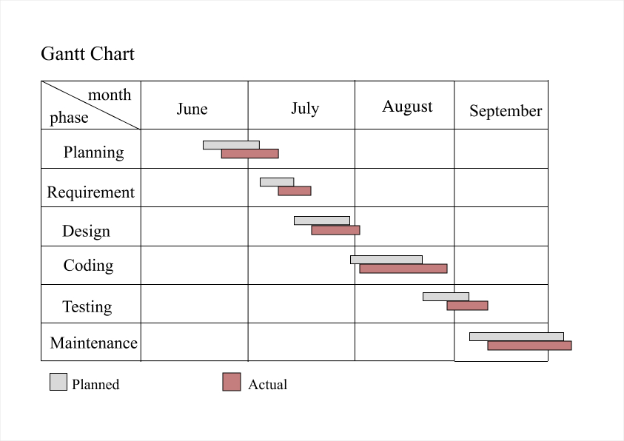

**UML DAIGRAM**

**ER DAIGRAM:**

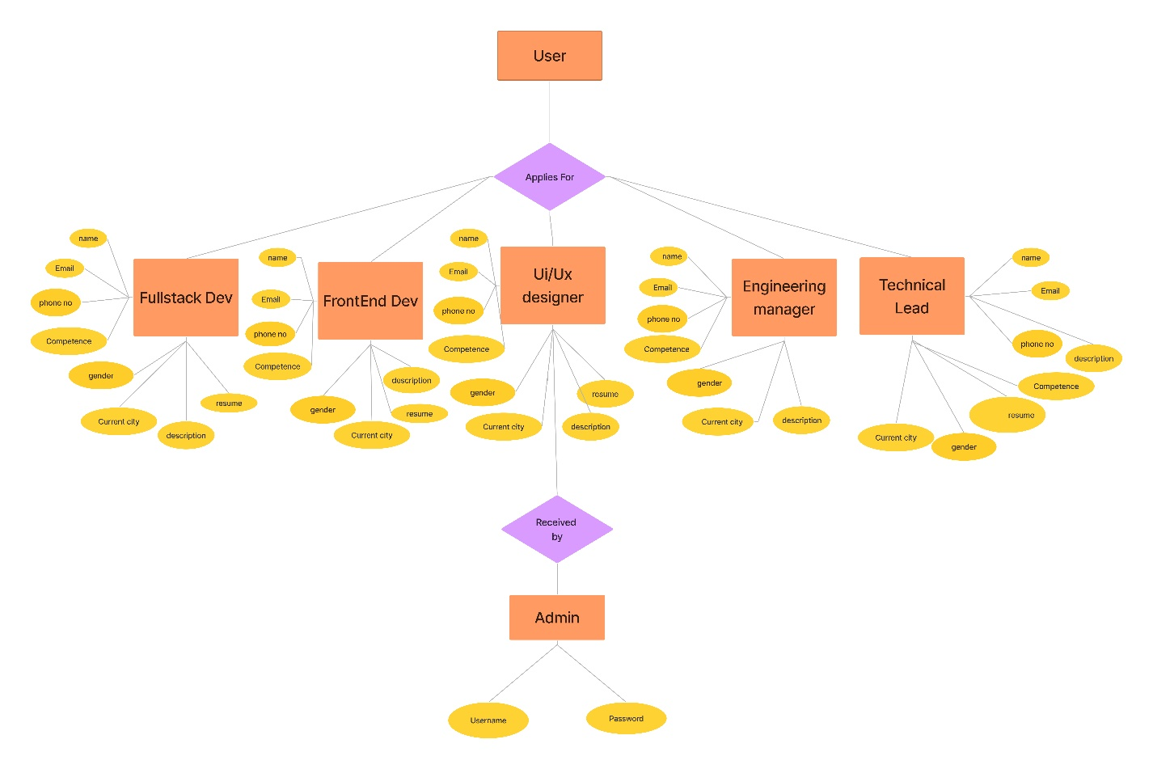

**EVENT TABLE:**

|  |  |  |  |  |  |
| --- | --- | --- | --- | --- | --- |
| **Event** | **Trigger** | **source** | **Activity** | **Response** | **Destination** |
| User check course available | Course inquiry | User | Look up available | Playlist, Get Documentation, All in one video available with notes | User |
| User apply for job | Job query | User | Form fill-ups | Checks correct info | Apply Now |
| User contact us | Insert query | User | Collects Query | Submitted Successfully | User |
| Admin | Insert username and password | Admin | Login in backend | Logged as Staff in backend | Admin |

**USE CASE:**

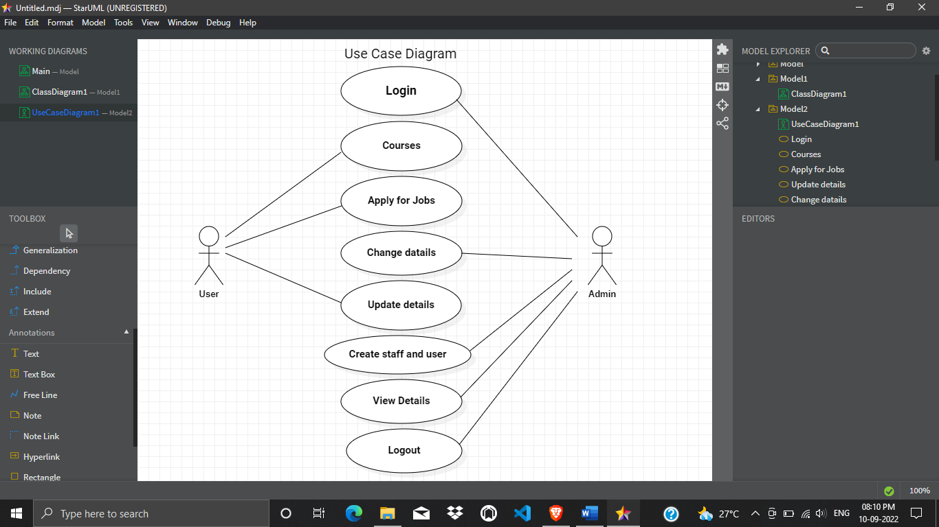

**CLASS:**

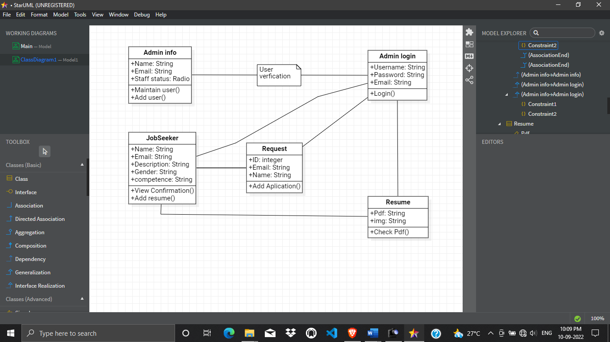

**SEQUENCE:**

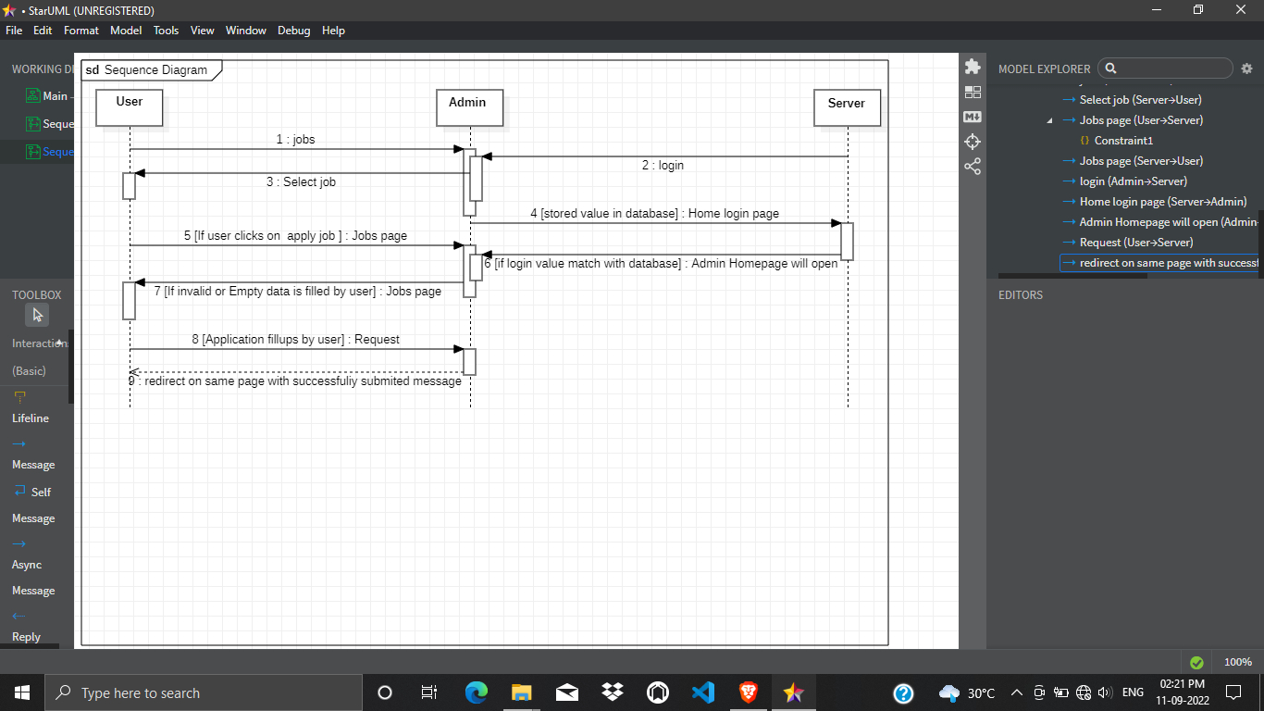

**STATE CHART:**

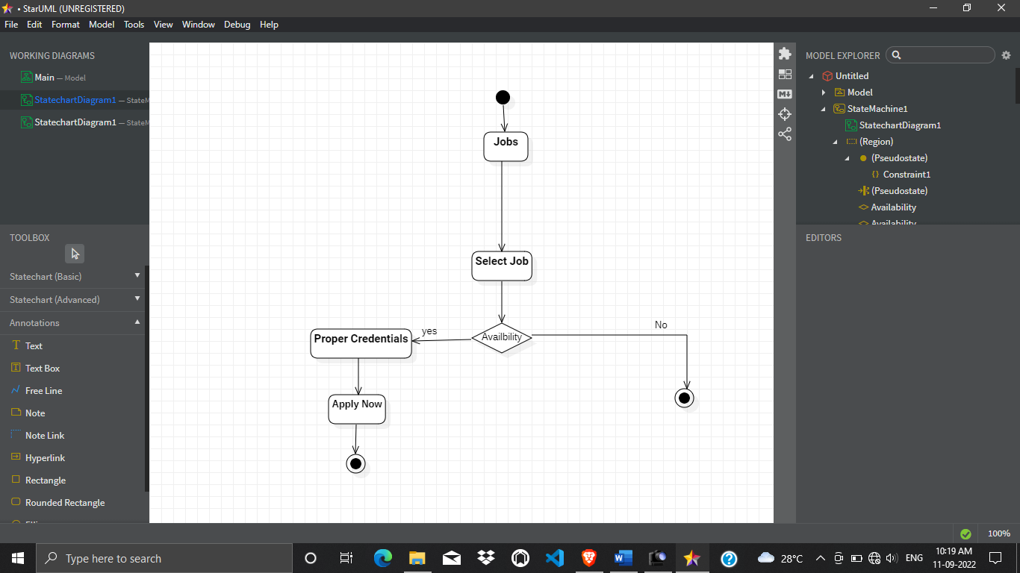

**SCHEMA DESIGN**

**Admin Table:**

|  |  |  |
| --- | --- | --- |
| **Column Name** | **Data Types** | **Constrain** |
| ID | int | Primary key, not null |
| Name | Varchar (25) | Not null |
| Email | Varchar (25) | Unique |
| Password | Varchar (25) | Not null |

**User Statement:**

|  |  |  |
| --- | --- | --- |
| **Column Name** | **Data Types** | **Constrain** |
| Id | int | Primary Key, not null |
| date | Date | Not null |
| Name | Varchar (25) | Not null |
| Password | Varchar (25) | Not null |
| Email | Varchar (25) | unique |

**Feedback Table:**

|  |  |  |
| --- | --- | --- |
| **Column Name** | **Data Types** | **Constrain** |
| Id | Int | Primary Key, not null |
| Message | Varchar(max) | Not null |
| Date | Date | Null |

**Contact Table:**

|  |  |  |
| --- | --- | --- |
| **Column Name** | **Data Types** | **Constrain** |
| Name | Varchar (25) | Not null |
| Phone | int | Primary Key, not null |
| description | Varchar(max) | Not null |

**CODING**

**SCREENSHOTS**

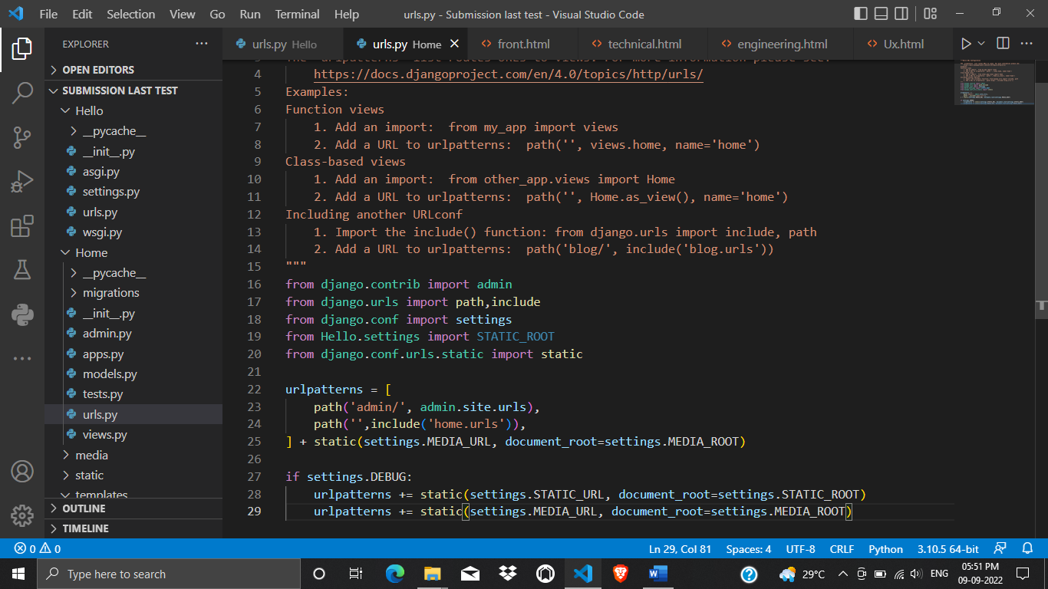

Web Application path logic – urls.py

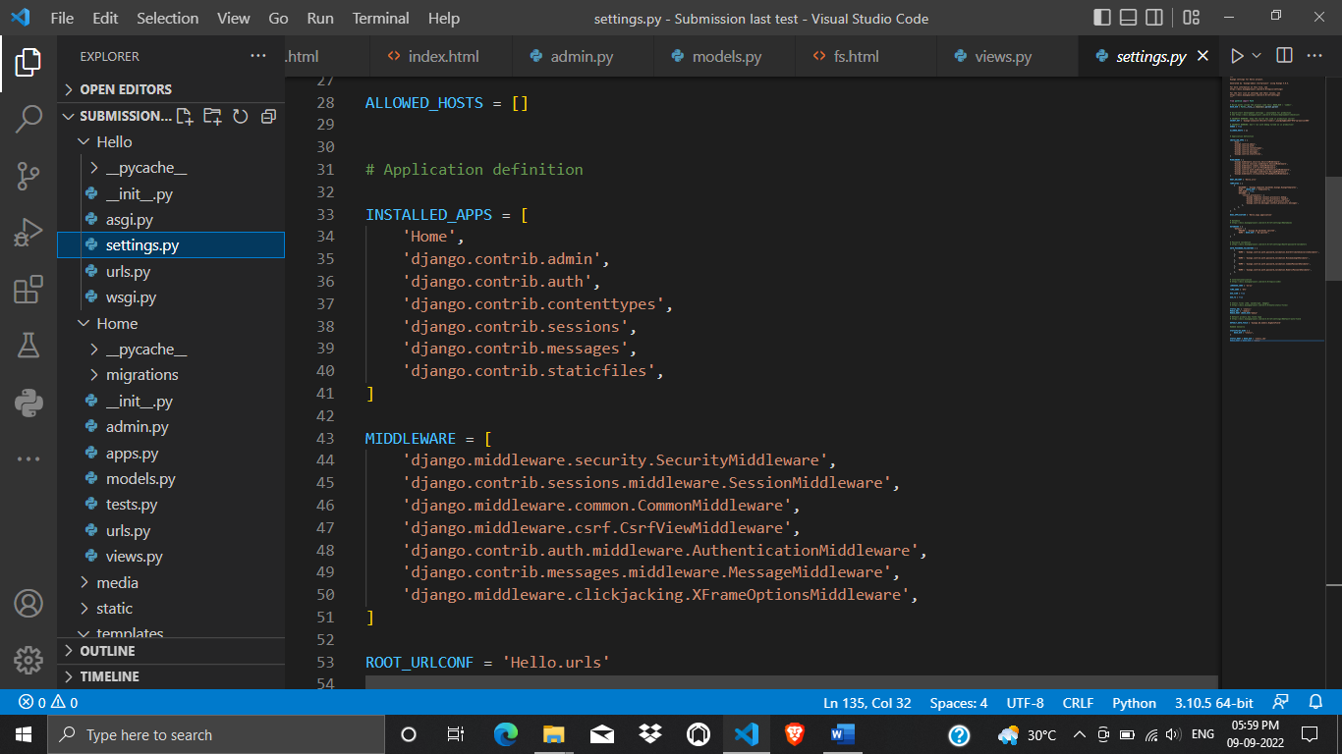

Install apps in setting.py

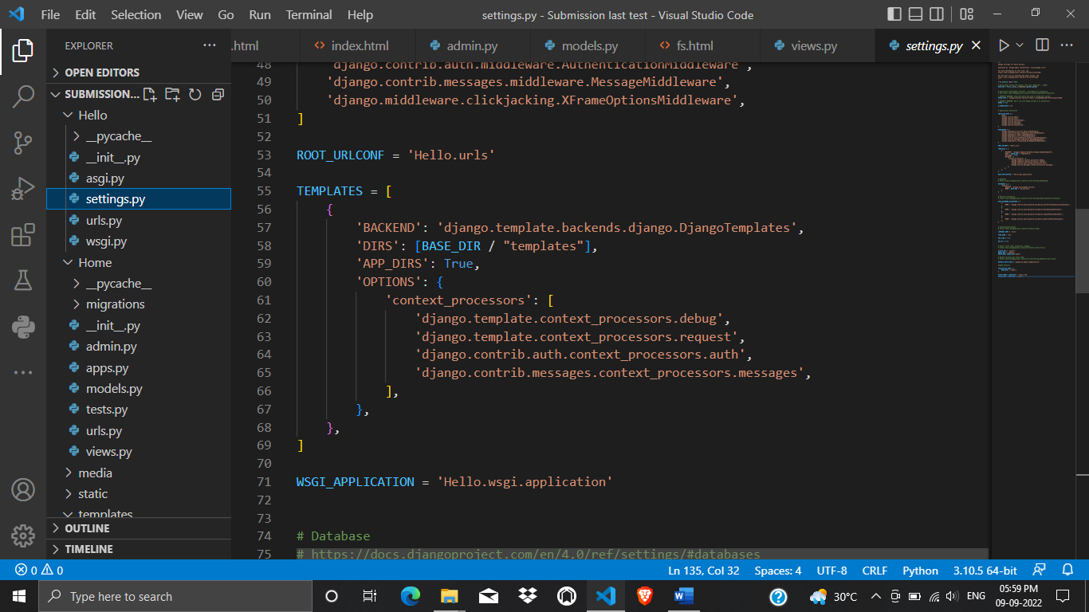

Templates code – settings.py

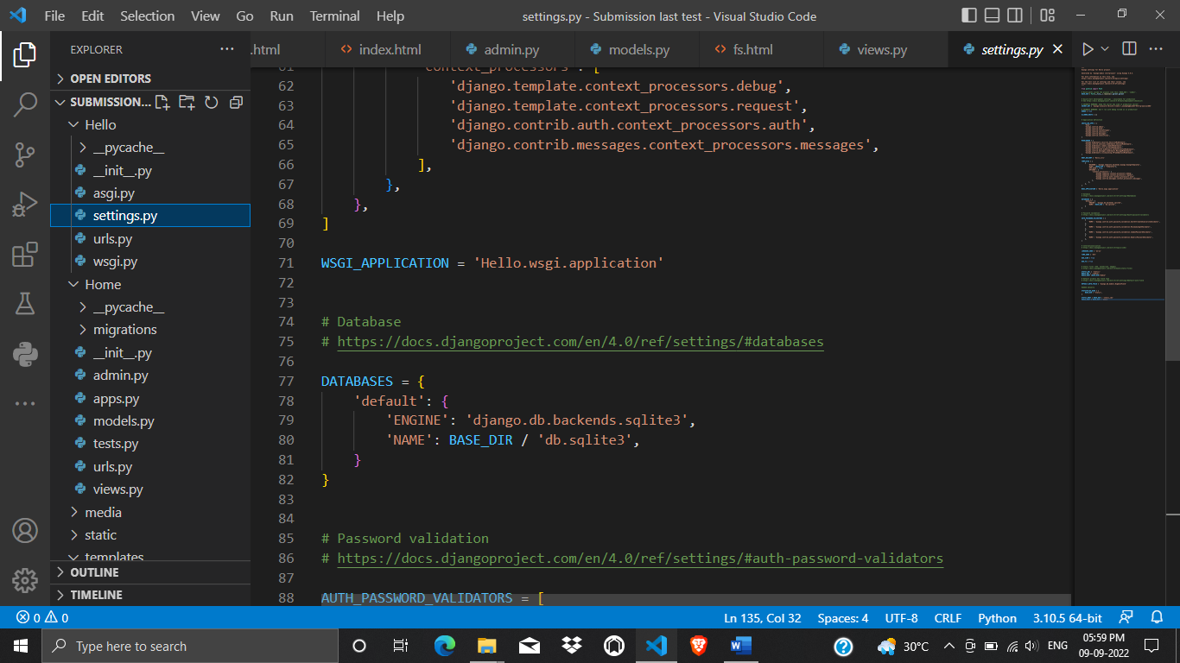

Database directory – Settings.py

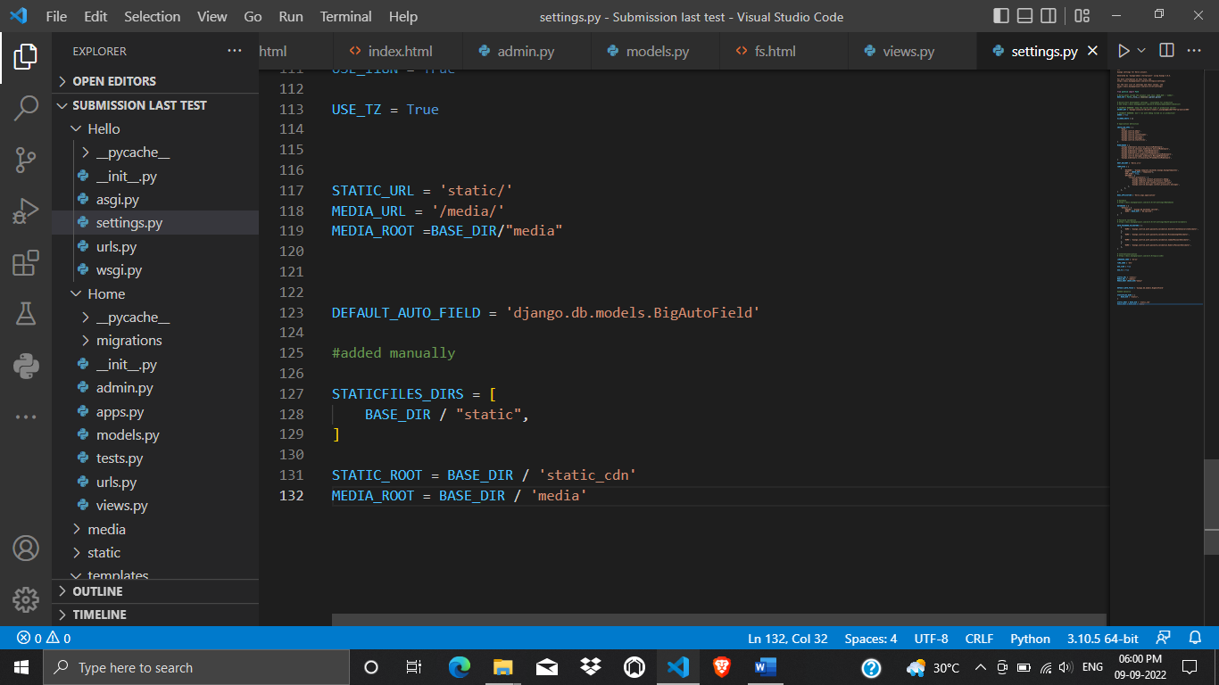

Static and Media – Settings.py

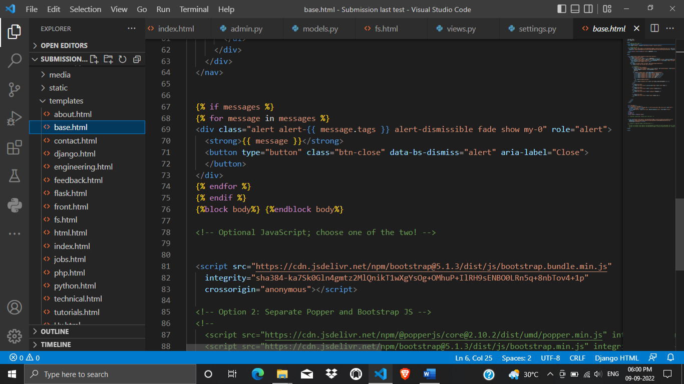

Logic of Messages - base.html

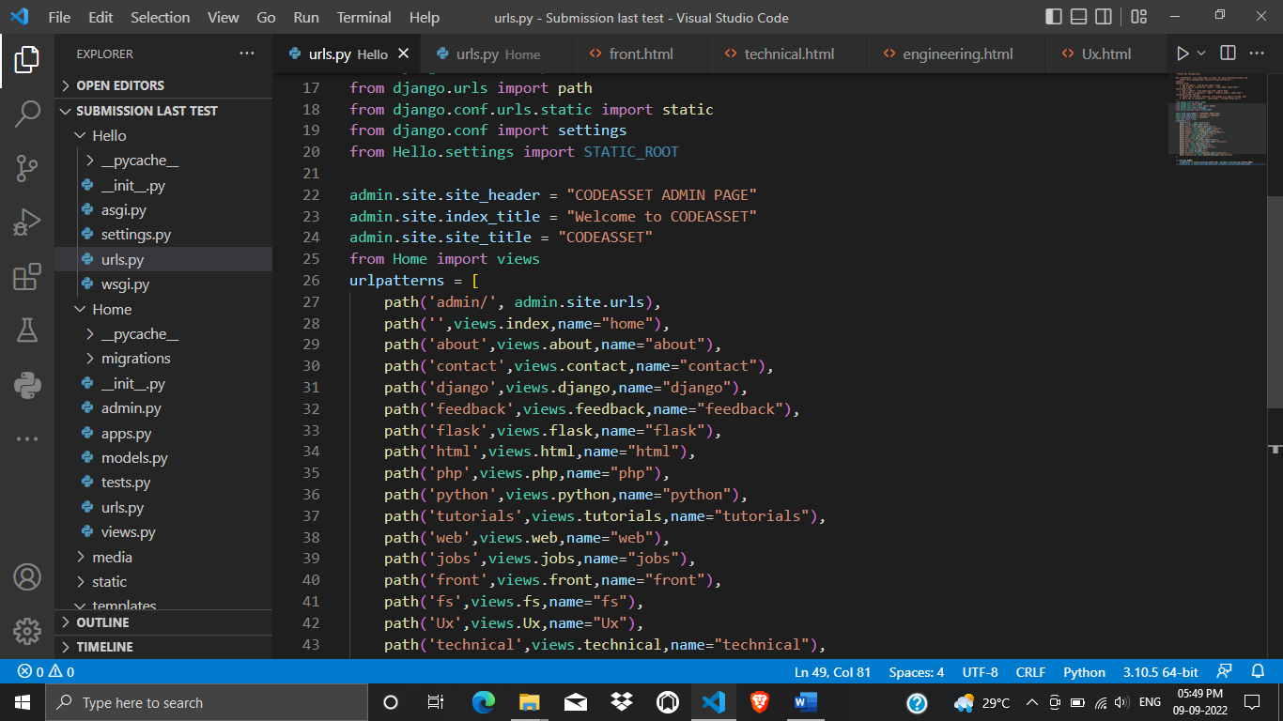

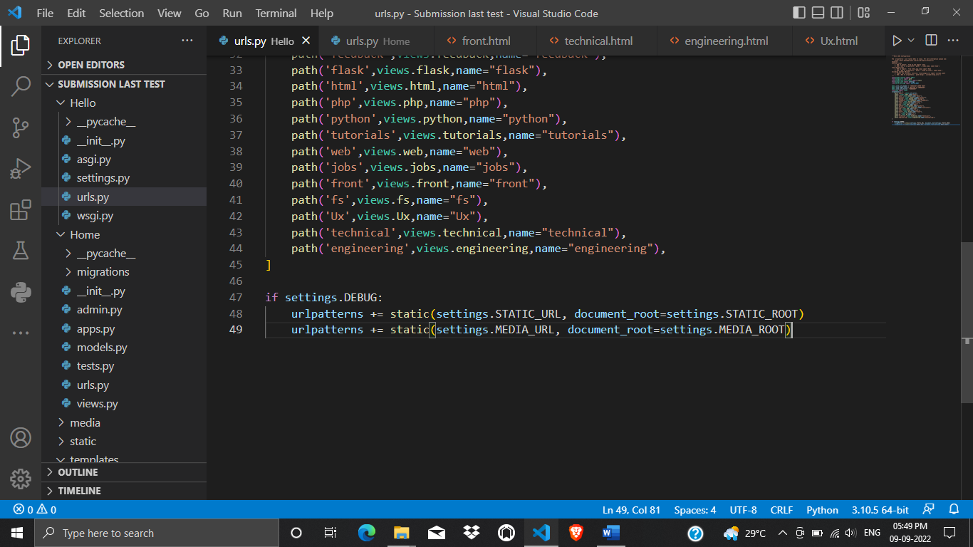

Web Project path logic – urls.py

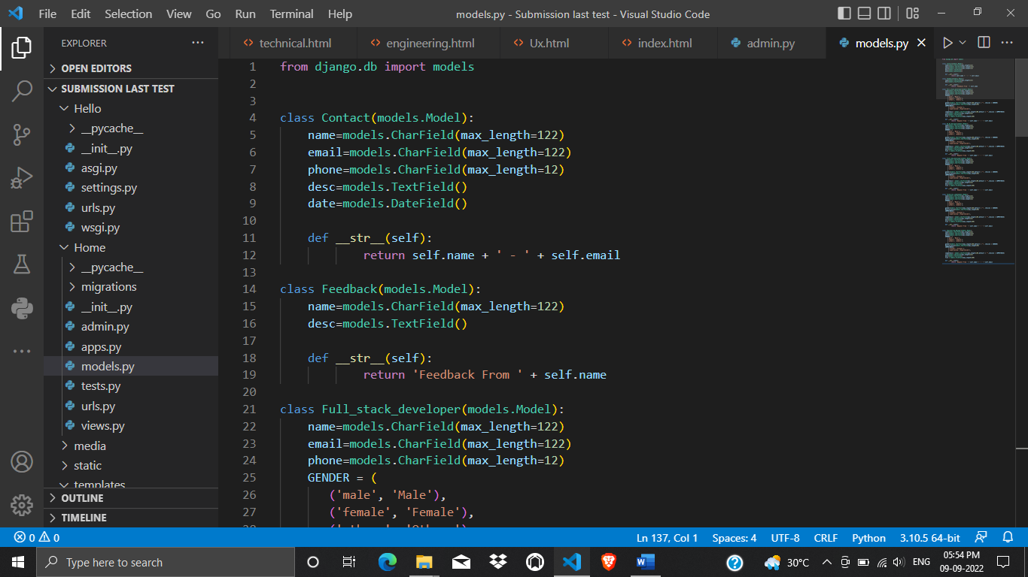

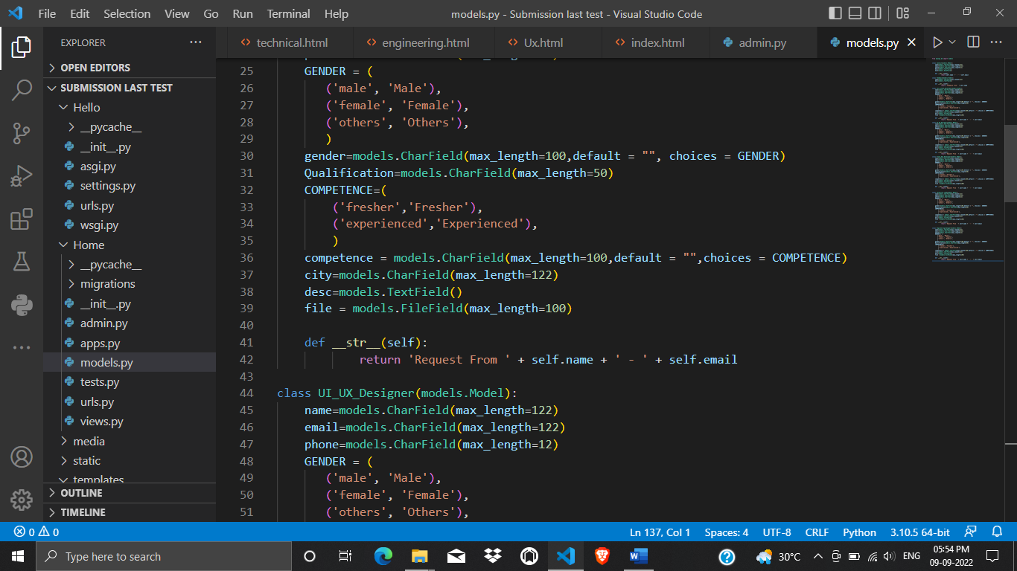

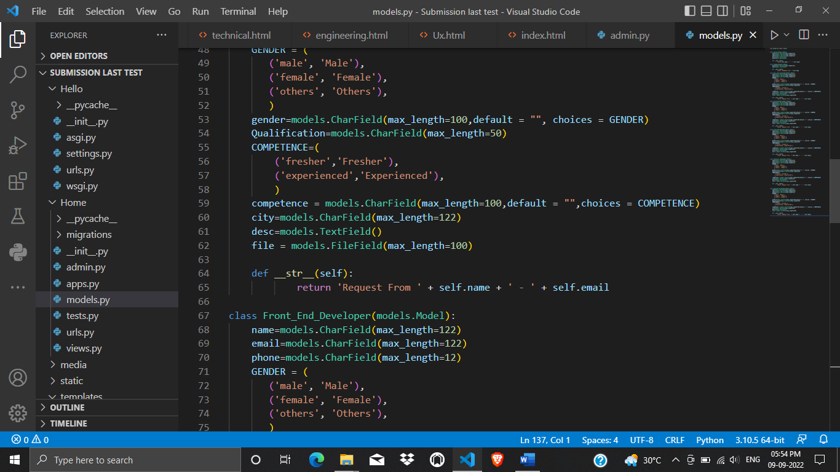

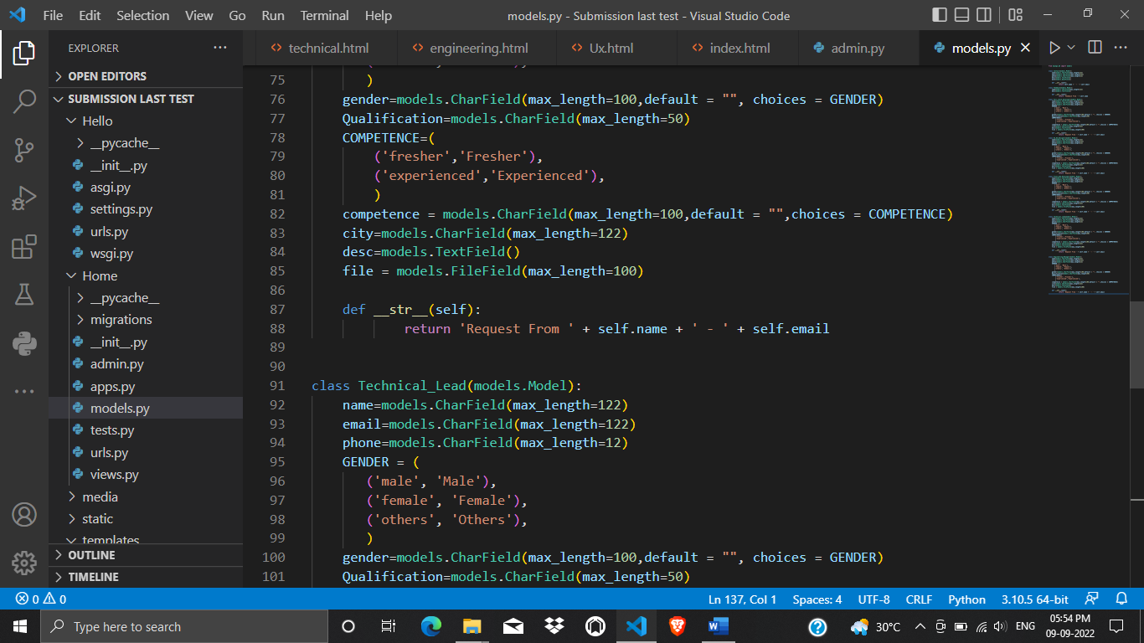

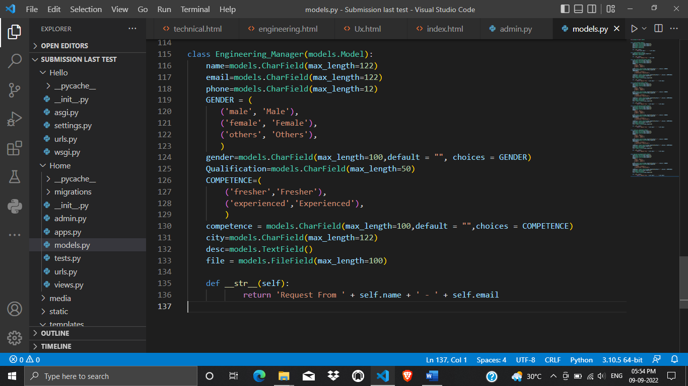

Table Models – Model.py

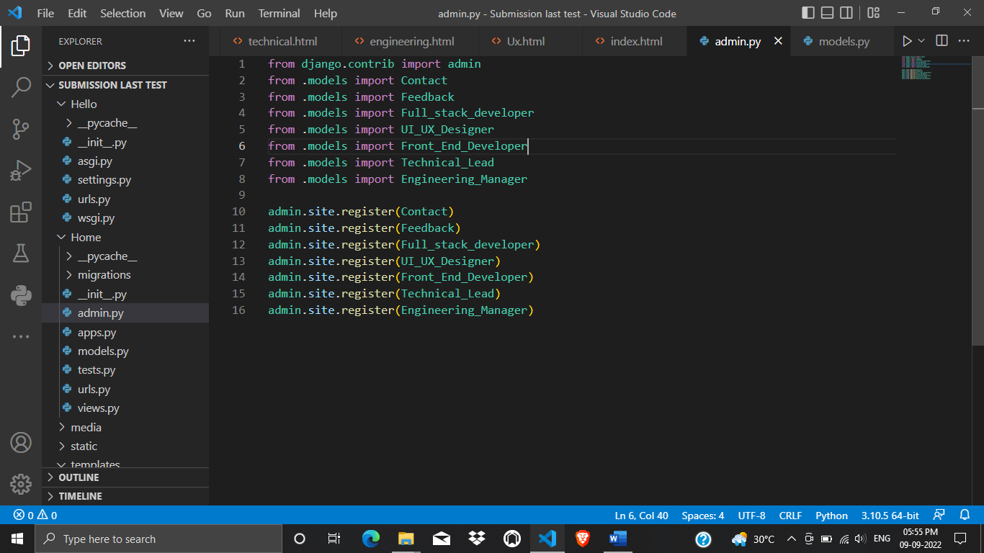

Admin Panel registration – Admin.py

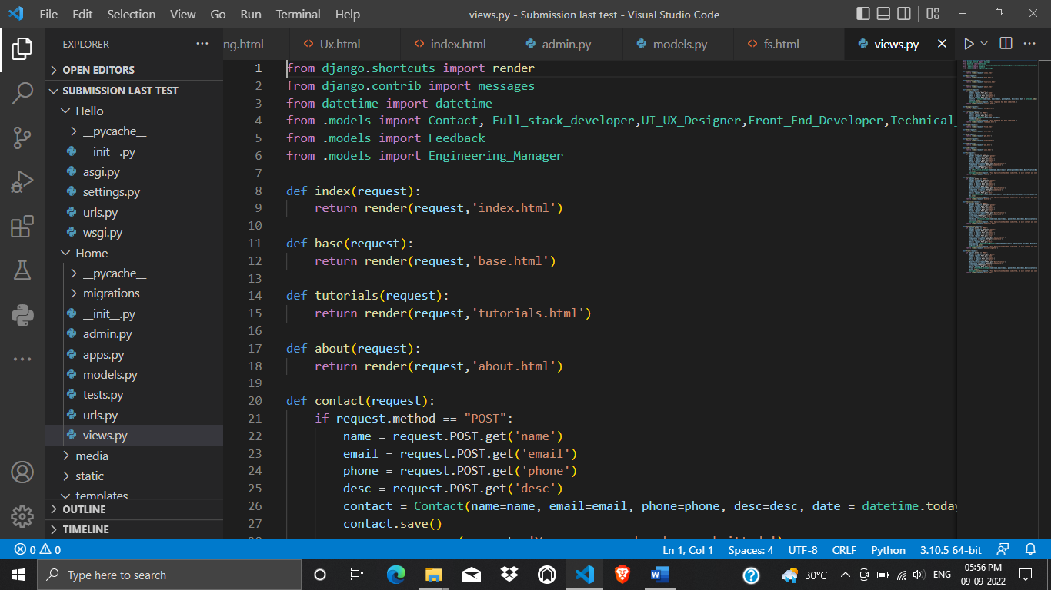

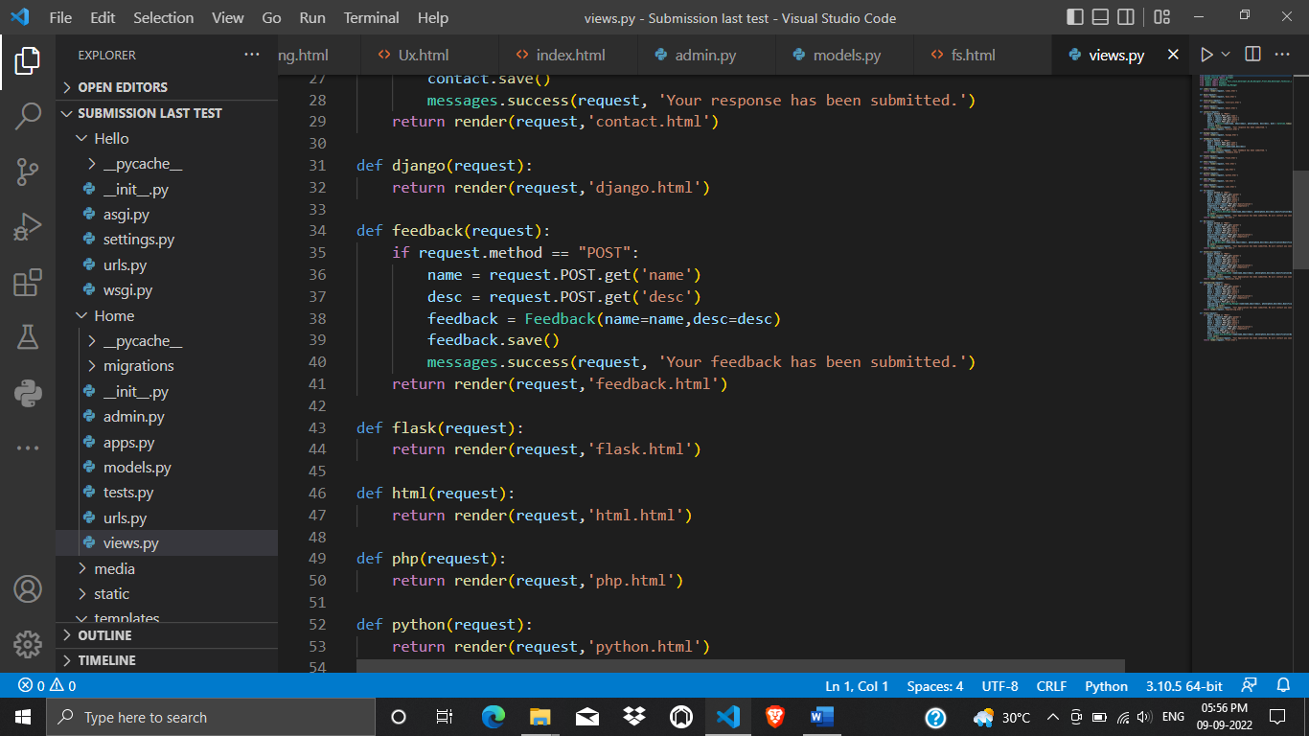

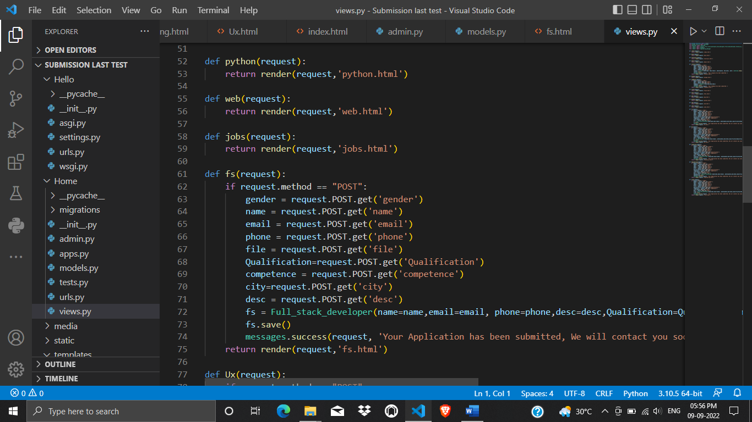

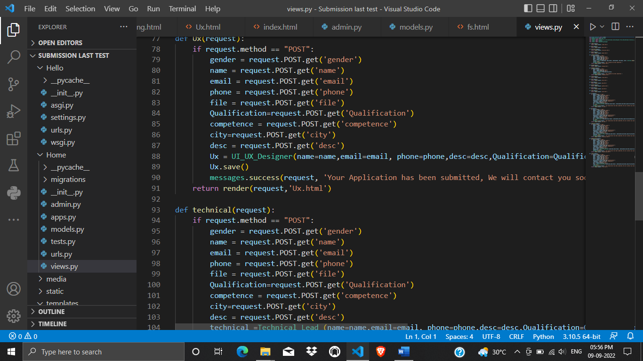

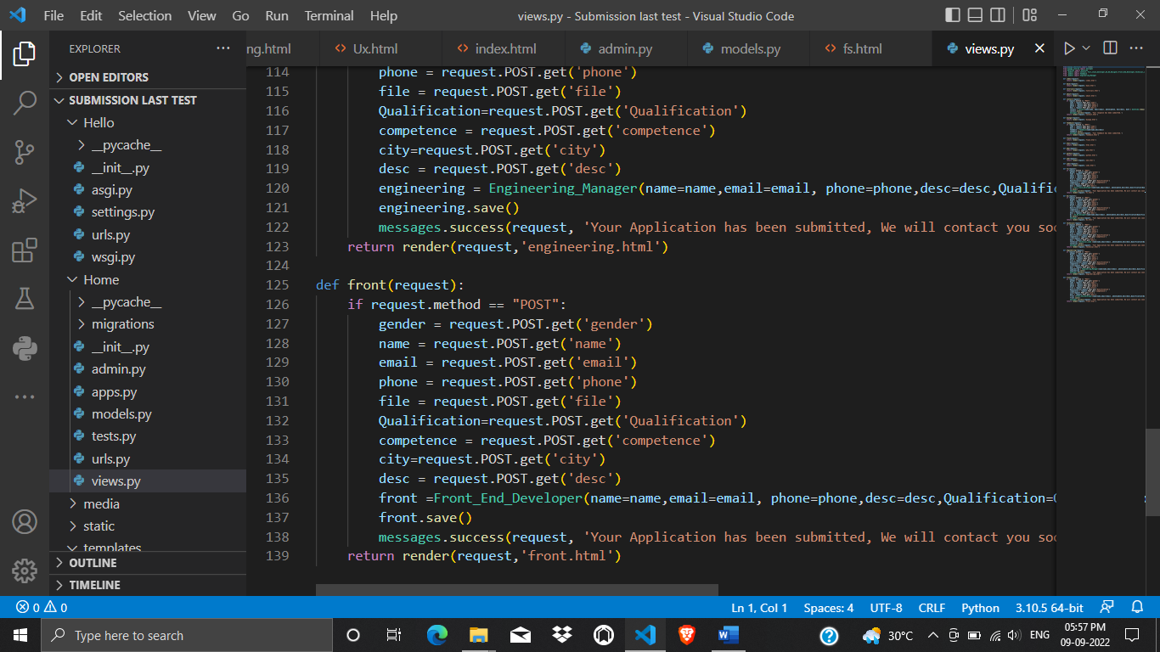

Views logic – Views.py

**IMPLEMENTATION**

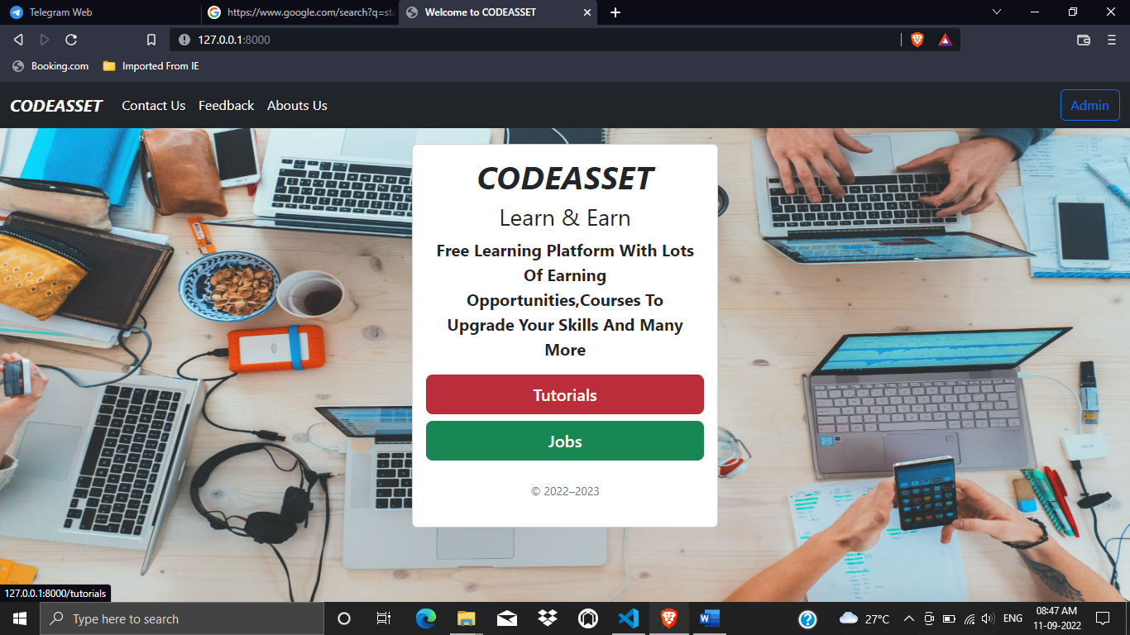

Homepage (index.html)

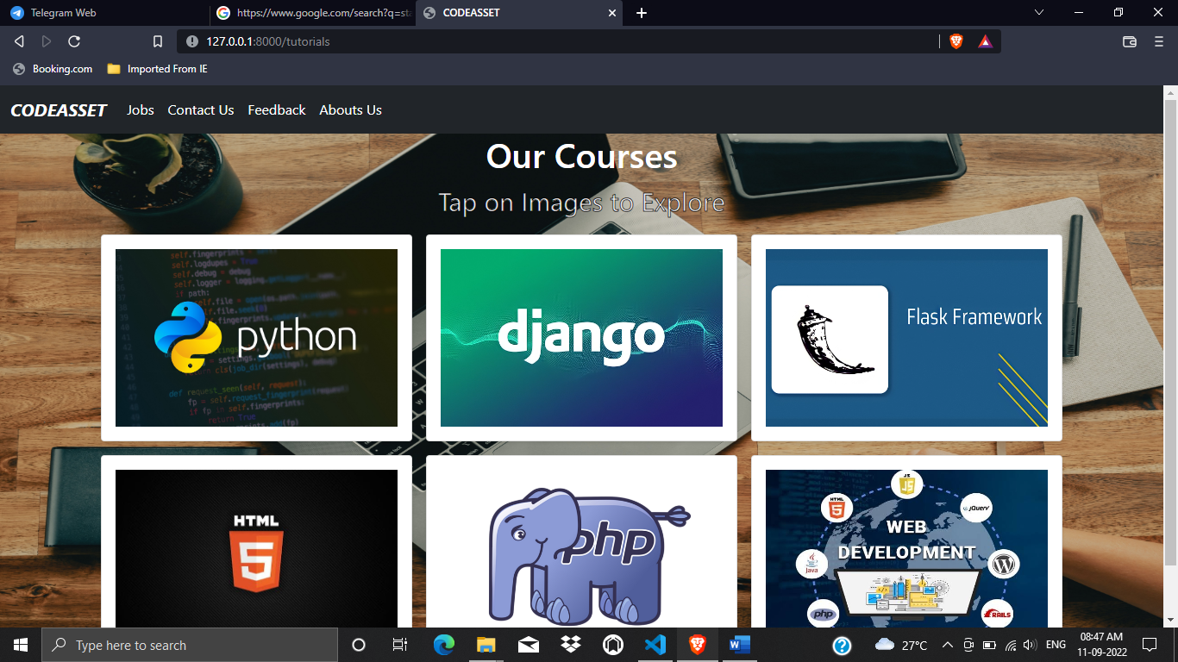

Tutorials page (tutorial.html)

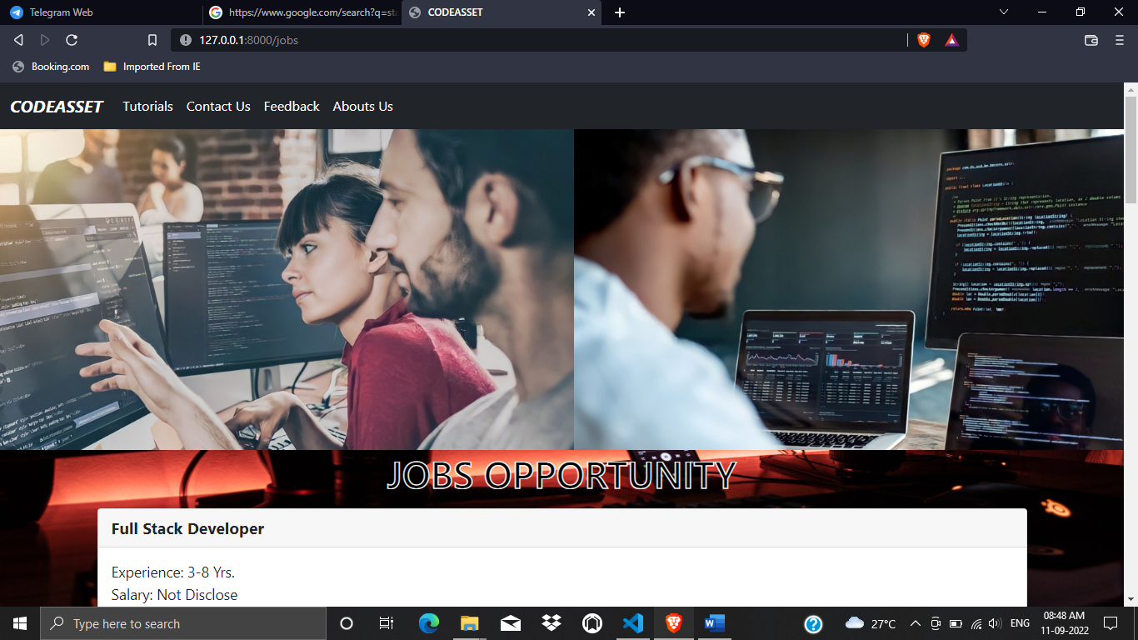

Job page (jobs.html)

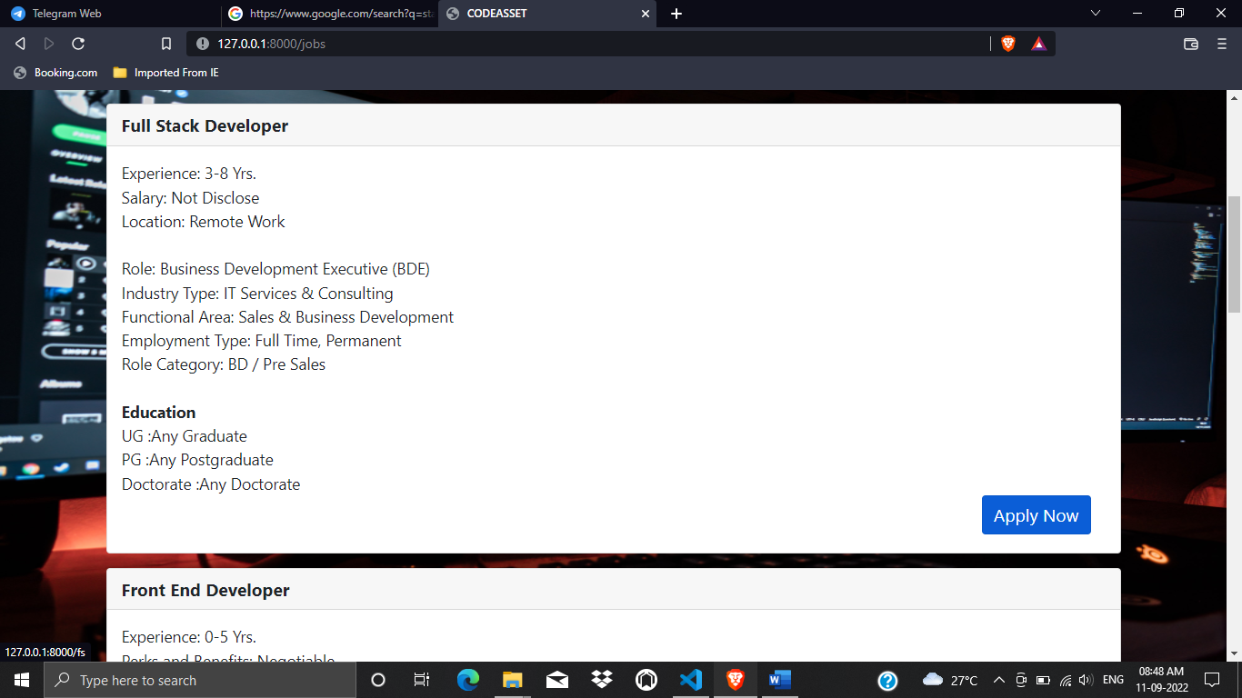

Job seeking UI

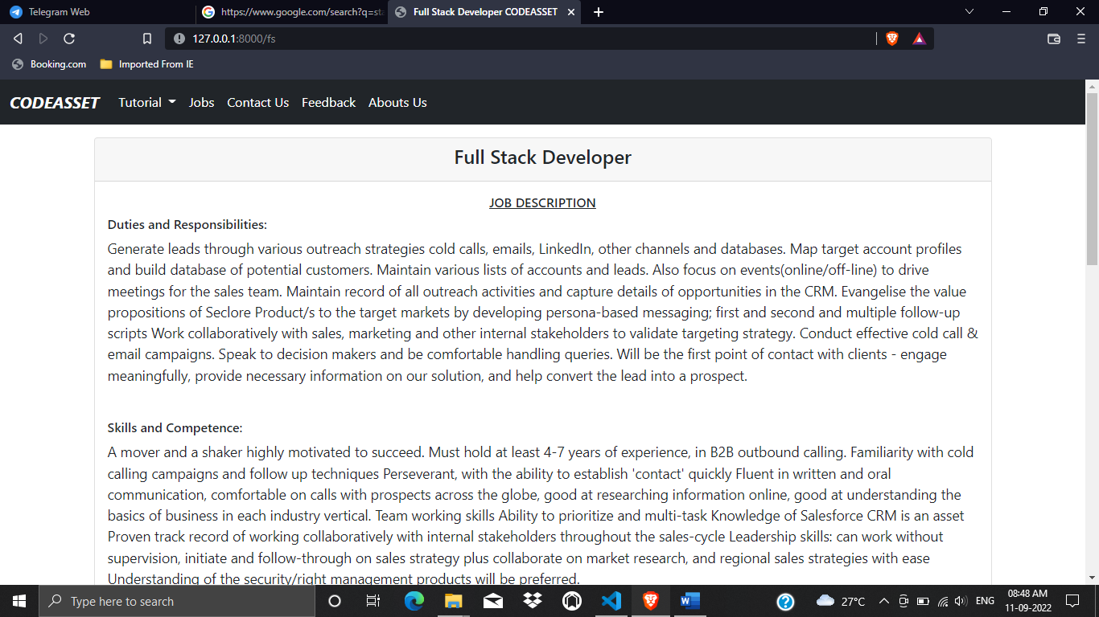

Jobs Description

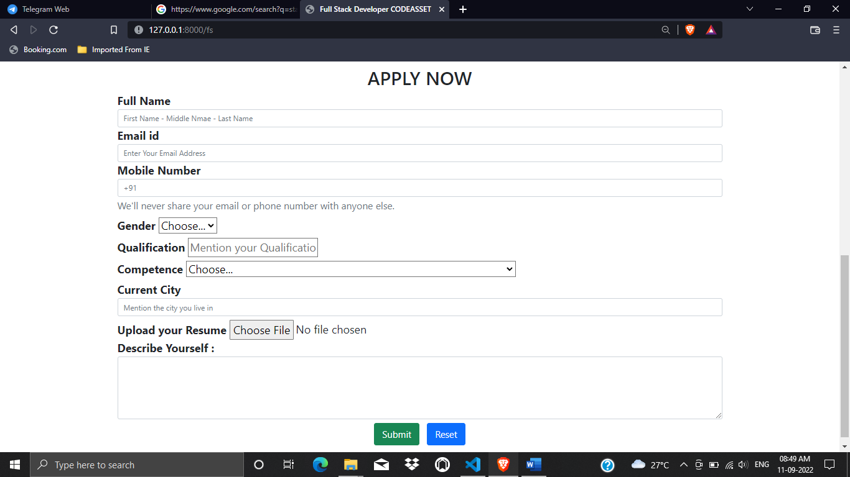

Application form

**TESTING (Validation & Test cases)**

|  |  |  |  |
| --- | --- | --- | --- |
| **Test cases** | **Input specified** | **Expected result** | **Actual result** |
| User login | Username=””  Password=”” | Username empty | Username empty |
| Username=” shivam”  Password=”abc03” | Verify and redirect to home page | Verify and redirect to home page |
| Email | Email=”” | Please enter email | Please enter email |
| Email=”12345er” | Please enter valid email | Please enter valid email |
| Email=” abc@gmail.com” | Valid credentials have been added | You are logged in now in admin panel |
| Date | Date=23/09/1998 | Please enter future date | Please enter future date |
| Date= | Please enter date | Please enter date |
| Date=20/10/2022 | Automatically enters and accepts date. | Automatically enters and accepts date. |

**REPORTS (final Output)**

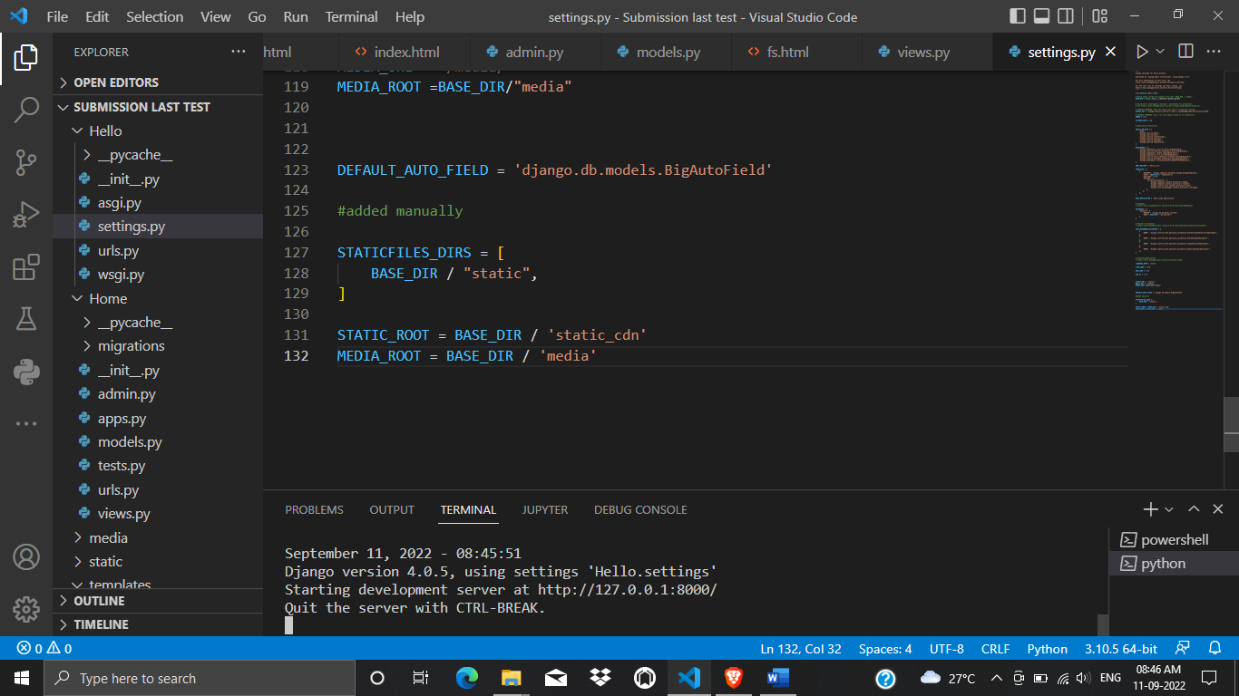

Working Server

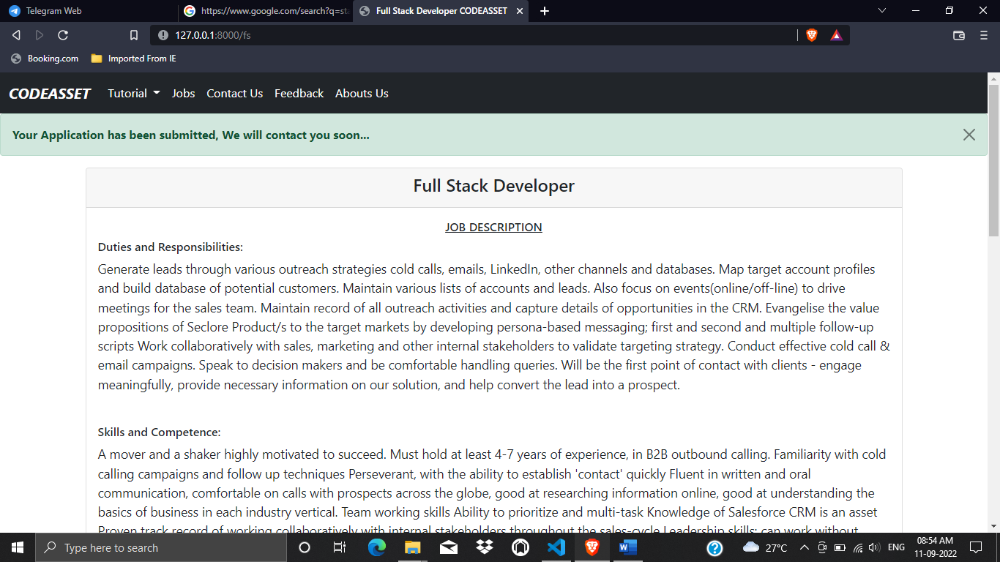

Application has been submitted

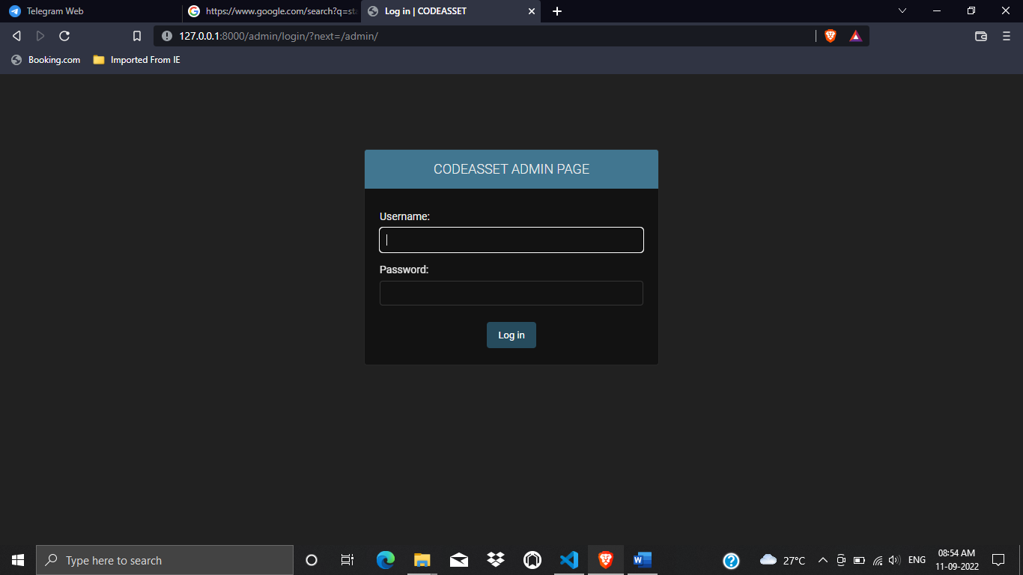

Admin login page

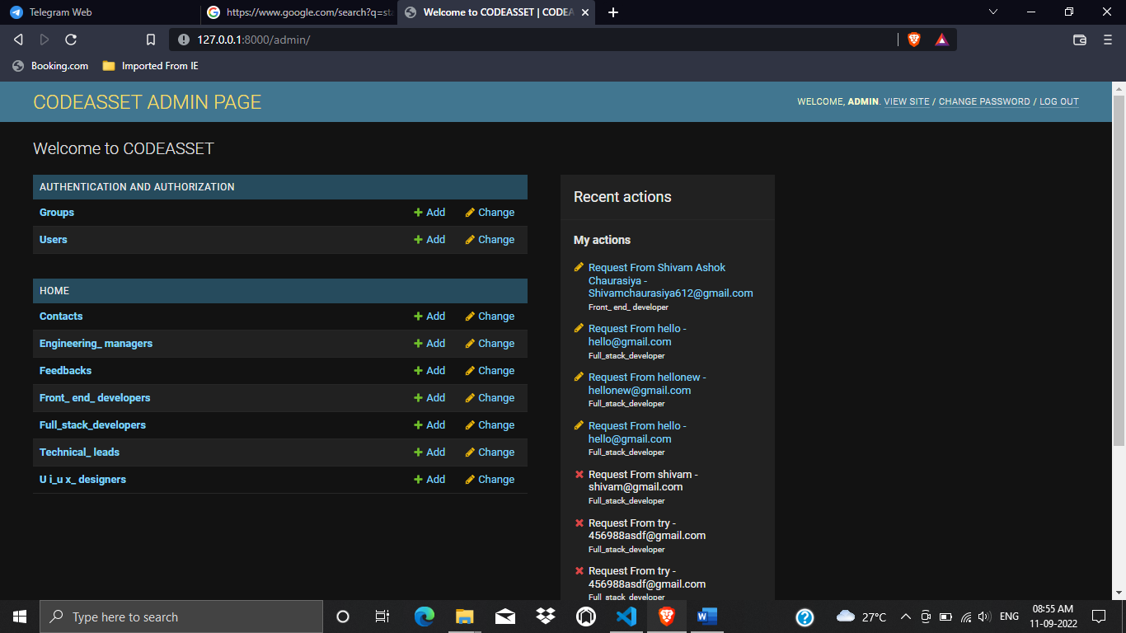

Admin Homepage Output

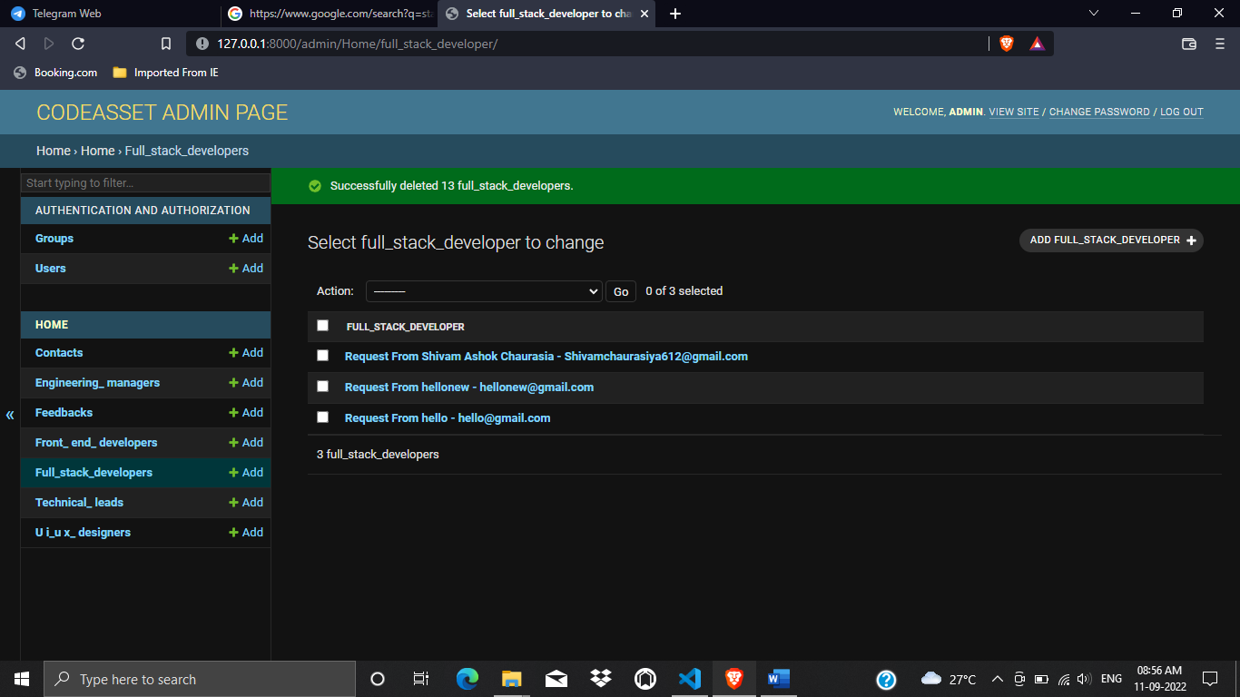

Job Requests Output

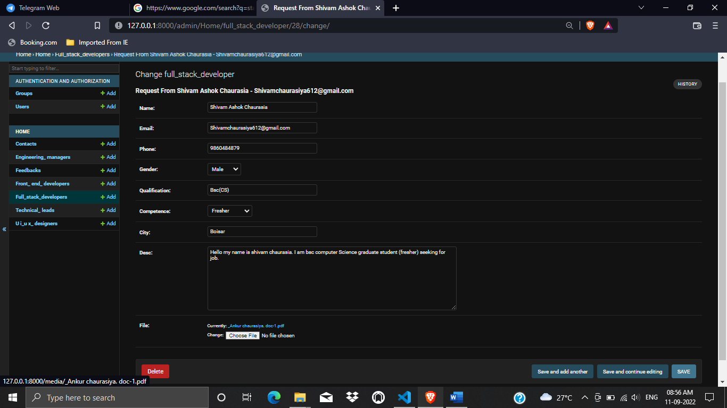

Application received by admin panel Output

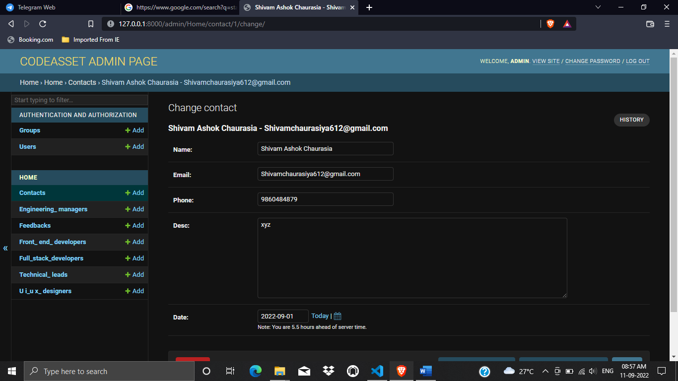

Contact details Output

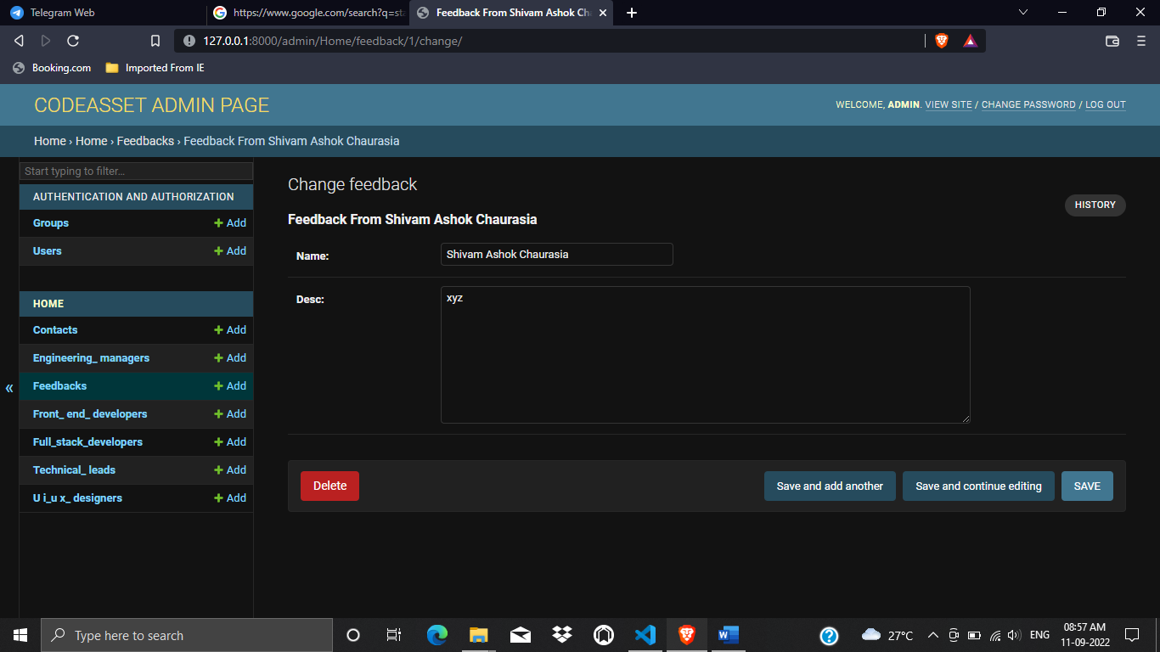

Feedback Output

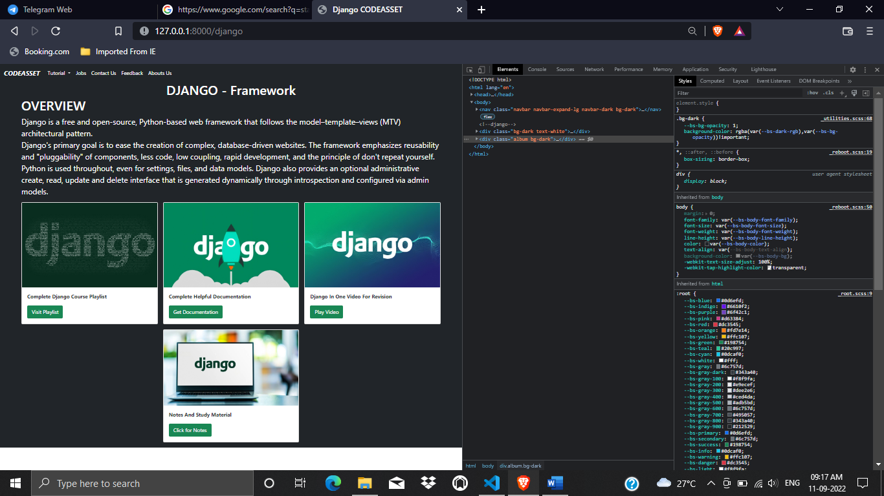

Tutorial Page Output

**CONCLUSION & FUTURE ENHANCEMENT**

**Conclusion: -**

To conclude, Project Data Grid works like a component which can access all the databases and picks up different functions. It overcomes the many limitations incorporated in the jobs and courses.

* Gives Opportunity
* A Free Learning Platform

**Future Enhancement: -**

The project has a very vast scope in future. The project can be implemented on intranet in future. Project can be updated in near future as and when requirement for the same arises, as it is very flexible in terms of expansion. With the proposed software of database Space Manager ready and fully functional the client is now able to manage and hence run the entire work in a much better, accurate and error free manner. The following are the future scope for the project.

**REFERENCE**

1.Stackoverflow

<https://stackoverflow.com/questions/7514964/django-how-to-create-a-file-and-save-it-to-a-models-filefield>

<https://stackoverflow.com/questions/31130706/dropdown-in-django-model>

2.W3School

<https://www.w3schools.com/html/html_images_background.asp>

3.geeksforgeeks

<https://www.geeksforgeeks.org/views-in-django-python/>

4. Codewithharry

<https://www.codewithharry.com/>

5.tutorialspoints

<https://www.tutorialspoint.com/python/index.htm>